INTRODUCING HP Recycled* Removable Adhesive Fabric made with recycled water bottles* & coating materials
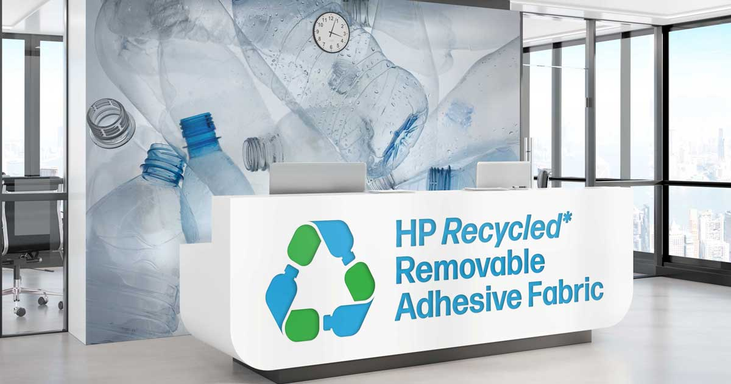
Our popular and versatile HP Removable Adhesive Fabric now comes in a version made with recycled water bottles* and coating materials! Specifically, 100% of total PET resin in this product is made from recycled water bottles,* helping to reduce plastic pollution.
Introducing HP Recycled* Removable Adhesive Fabric — with the same remarkable, repositionable adhesive that can be mounted to indoor or outdoor surfaces without leaving a residue, but now available to the growing market of eco-conscious print consumers.
HP Recycled* Removable Adhesive Fabric is:
- Slip resistant* for floor graphics* and REACH compliant*
- Compatible with HP large-format water-based ink technologies
- Comes on a 3-in core with a 2-in adapter
- Can be contour cut and applied without stretching
- AND it’s offered at a comparable price to traditional non-post-consumer recycled products*
We can make a difference through our everyday choices. HP Recycled* Removable Adhesive Fabric is the right choice for a multitude of applications.
To learn more about this unique product, or to order, contact us at XXX-XXX-XXXX, visit inserturl, or email info@yourwebsite.

- For additional product information including technical specifications visit [insert url].

